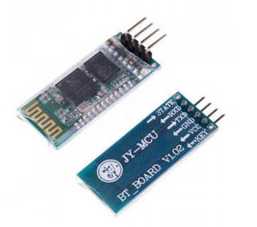
HC06 Bluetooth sensor is a device to communicate with other bluetooth device. This project will show how to send a character from an Android bluetooth app to Arduino serial monitor window.
Step 1: connect the HC06 bluetooth sensor to arduino as per following graph:
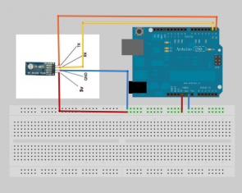
Step 2: Download Amarino app into your android cell phone or other android device. Open the app and search the bluetooth device “HC06″ and pair it with android device. use the default passcode “0000” or “1234”.
Step 3: Download sketch code and load it into arduino.
Step 4: Type a character “a” in android app, and you will see character “a” showing on the arduino serial monitor.

